The Global Language of Business

2018 1st Quarter Executive Summary
Global Standards Management Process (GSMP)
GS1 Standards Events

This past March, 206 attendees from 22 countries joined us in Jersey City to build the future of global business standards. There was a full week of work group sessions, where over 30% of our attendees were attending for the first time. This reflects the increasing relevance and diversity of the efforts underway such as the Mobile Ready Hero Image, Fighting Illicit Trade and the Consumer Product Variant as well as the Standards Development Certification Programme.

Our plenary emphasised the importance of the people and their tireless commitment that truly drives the creations of global standards. It is the GSMP community who leverage their expertise to make a difference in today's world through standards. You can find more details on event via the link: Executive Summary of 2018 Standards Event.

Thank you for your continued support and please continue to drive participation, as a standard is only as good as those who help build it.

We hope you plan to join us at the next GS1 Industry & Standards Event in Dublin, Ireland during the week of 10 September 2018. This is an outstanding opportunity for your organisation to take part in influencing the future of global business!

Andrew Hearn; Vice President, GSMP

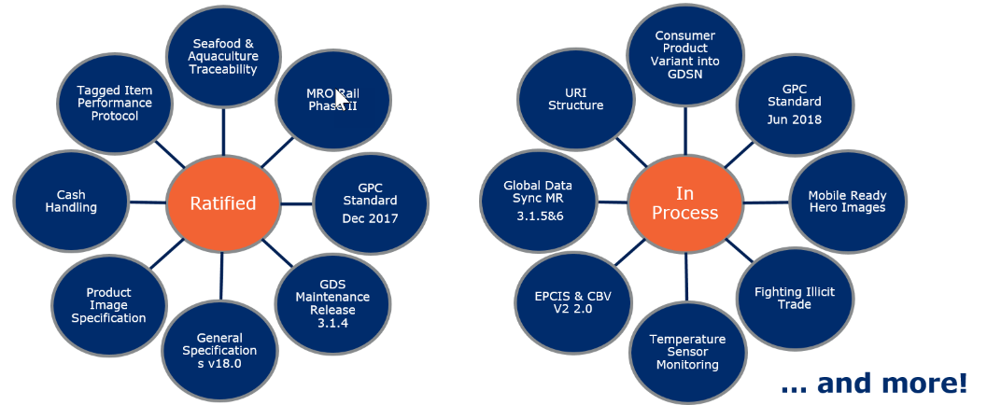
New Work Standards Develop Work
Pharmaceutical Clinical Trails and EPCIS CBV v2 are 2 new work efforts that started this quarter to join several other groups that have been working hard to develop standards.

Are you and your communities’ interests represented?

To find out more about these efforts and to stay up to date on the next significant work effort that may affect you and your community, click the link to see the latest updates from GSMP.
Mission Specific Groups Status Overview
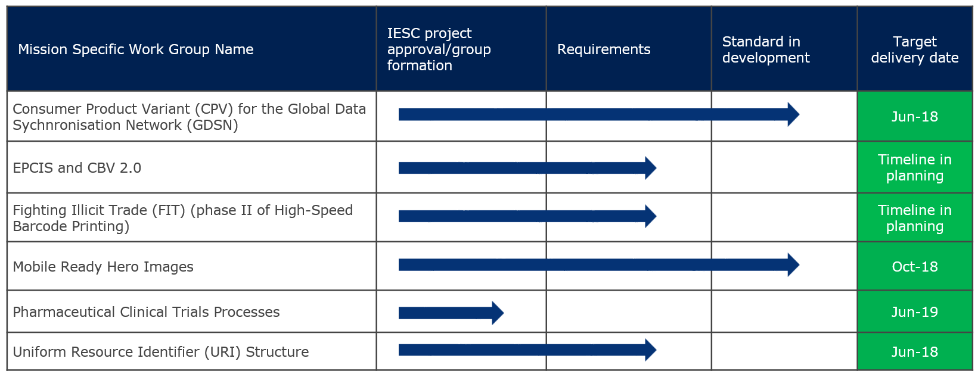
Legend: on-target at risk will not meet target completed
Global Standards Management Process (GSMP) Team

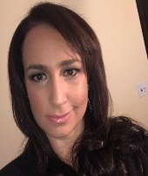
Jean-Luc Champion
Manager, Standards Development
David Buckley
Senior Manager, Technical Publications and Standards Development
Justin Childs
Director, Standards Development
Cindy Grell
Manager,
Community Engagement, Communications & Events

Eddy Merrill
Operations Analyst, GSMP
Eileen Harpell
Operations Manager, GSMP
Andrew Hearn
Head of Standards Development
Jeanette McVeigh
GPC Standards Development Leader
John Ryu
Director, Standards Development
Greg Rowe
Director, Standards Development

