Global Standards Management Process (GSMP) 2018 Q1 2018 Management Report
An update on key facts and figures
Release 1.0, January – March 2018

Table of Contents
1 Introduction 3
2 Standards and guidelines are created through the GSMP 4-Step Process 3
3 Standards and guidelines delivered in 2018 3
3.1 Delivered in Q1 3
3.2 Projects status 4
3.3 Work request activity 4
3.4 Top 11 work request submitters 6
3.4.1 Work request aging report 6
3.5 Standards Development Work Group 6
3.5.1 Standards Maintenance Groups (SMGs) 7
3.5.2 Mission-specific Work Groups (MSWG) 7
3.5.3 No Mission-specific Work Groups were closed this quarter 7
3.6 Performance 7
3.6.1 Standards maintenance work 7
3.6.2 Development work 9
4 Participation 9
4.1 GSMP company membership 10
4.2 Voting 11
4.3 Event attendance 11
5 Quality 11
5.1 Due process 11
5.2 Consensus 12
5.3 Satisfaction survey results 12
5.3.1 GSMP member satisfaction survey 12
5.3.2 GS1 Standards events satisfaction survey results 13
5.3.3 GS1 Member Organisation satisfaction survey 13
GSMP Governance Groups 13
5.4 Board Committee for Standards (BCS) members 13
5.5 Industry Engagement Steering Committee (IESC) members 14
5.6 Architecture Group (AG) members 14
More information 14

Introduction
The Global Standards Management Process (GSMP) is a community-based process for creating deliverables that serve the GS1® community.
The deliverables from GSMP are:
- GS1 standards: documents that trading partners agree to follow in order to achieve interoperability goals. The rules that must be followed are called normative statements.
- GS1 guidelines: non-normative documents that assist individual organisations in understanding and applying GS1 standards.
- Collateral materials: other documents that provide an understanding of GS1 standards and GS1 guidelines and how to use them.
GSMP is measured by activity, performance, participation and quality. This report contains measurements for the first quarter of 2018.

Standards and guidelines are created through the GSMP 4-Step Process
Figure 2-1 GSMP process
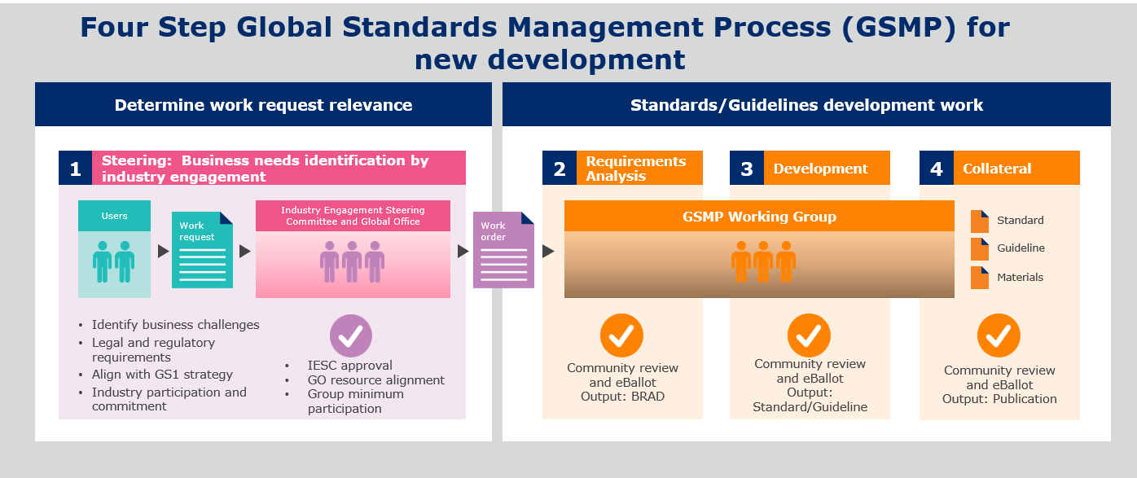

Standards and guidelines delivered in 2018

Delivered in Q1
GDSN Maintenance Release 3.1.5 was published and is scheduled for 12 May 2018. It is a small GDSN release which will addition of optional attributes and Efficient Code List (ECL)
Updates to the GDSN Trade Item Implementation Guideline for
- Clarification implementation of components Efficient Code List (ECL)
- Additions to the Unit of Measure (UoM) code

Updates to the Core Business Vocabulary Standard for Tax ID

Updates to the Global Fish, Seafood and Aquaculture Implementation Guideline to aid in the adoption of consistent business practices to effectively manage traceability for the seafood industry

Projects status
Figure 3-1 Project status graphic
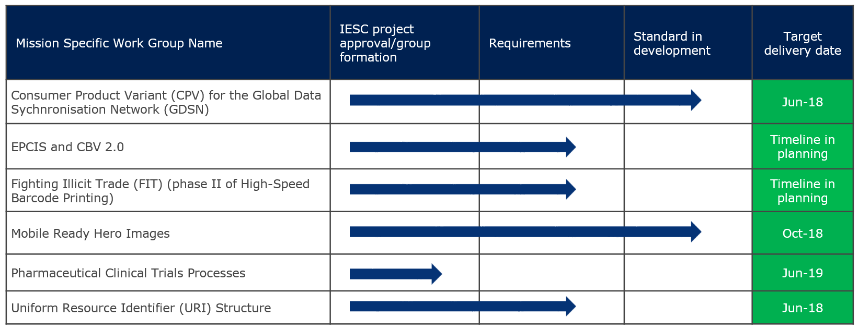
Legend:

on-target at risk will not meet target complete

Work request activity
Work requests (WR) entered for new standards or modifications to existing standards.
- 88 work requests were entered this quarter, in line with 86 in Q1 of 2017 and little above the average of 79 WRs entered each quarter of 2017
- 80 work requests closed this quarter, in line with the average of 82 WRs closed each quarter of 2017
58%
Submitted to GMD SMG
Figure 3-2 Work requests submitted to Standards Maintenance Groups in this quarter

Work request activity is classified and reported in several ways below:
Table 3-1 Work requests submitted for each standard
Standard | 2015 | 2016 | 2017 | 2018
Automatic Identification Data Capture (AIDC) * | 27 | 31 | 23 | 5
Electronic Data Interchange (EDI) (Transactional Data) | 37 | 118 | 35 | 0
Electronic Product Code (Tag Data Standard & UHF) | 6 | 3 | 4 | 0
EPCIS & Core Business Vocabulary (CBV) | 2 | 3 | 3 | 2
GDSN Package Measurement Rules | 5 | 6 | 3 | 0
GLN Services | 0 | 0 | 1 | 0
Global Data Synchronisation | 218 | 240 | 190 | 46
Global Product Classification | 77 | 123 | 39 | 32
Global Traceability Standard | 5 | 1 | 4 | 0
Product Image Specification | 3 | 10 | 2 | 2
Tagged item Performance Protocol | 0 | 0 | 2 | 0
Other (Process, SmartSearch, New Standards..) | 3 | 0 | 9 | 1
Total | 383 | 535 | 315 | 88
Table 3-2 Work requests submitted by category
Category | 2015 | 2016 | 2017 | 2018
Maintenance | 368 | 526 | 295 | 81
Development | 15 | 9 | 7 | 7
In assessment/unknown | 0 | 0 | 12 | 0
Total | 383 | 535 | 314 | 88
Table 3-3 Work requests submitted by region
Region | 2015 | 2016 | 2017 | 2018
Asia Pacific | 10 | 9 | 12 | 1
Europe | 198 | 378 | 191 | 59
Latin America | 0 | 1 | 3 | 28
North America | 175 | 147 | 109 | 0
MEMA | 0 | 0 | 0 | 0
Total | 383 | 535 | 315 | 88

Table 3-4 Work requests submitted by member type
Member type | 2015 | 2016 | 2017 | 2018
Global Office | 28 | 22 | 34 | 8
Member Organisation | 229 | 364 | 194 | 67
Users | 126 | 149 | 86 | 13
Total | 383 | 535 | 314 | 88

Top 11 work request submitters
Figure 3-3 Top work request submitters
Organisation | 2015 | 2016 | 2017 | 2018 | Totals
GS1 Belgium & Luxembourg * | 5 | 0 | 3 | 22 | 30
GS1 Netherlands * | 34 | 43 | 39 | 14 | 130
1WorldSync Holdings, Inc. | 100 | 86 | 55 | 11 | 252
GS1 Canada * | 14 | 21 | 22 | 8 | 65
GS1 France * | 16 | 43 | 33 | 6 | 98
GS1 US * | 49 | 32 | 14 | 6 | 101
GS1 Czech Republic | 1 | 6 | 8 | 2 | 17
GS1 Denmark | 1 | 8 | 5 | 2 | 16
GS1 Germany | 77 | 161 | 15 | 2 | 255
GS1 Sweden | 11 | 12 | 14 | 2 | 39
PepsiCo, Inc | 5 | 2 | 2 | 2 | 11
* Top 5 GS1 Member Organisation submitters for Q1

88%
Of all WRs submitted Q1

Work request aging report
90 work requests remain open at quarter-end
Table 3-5 Overall aging report in days
Days open = WR submission to end of quarter | Under 100 | 100-200 | 200-500 | Over 500 | Total
GSMP Maintenance | 53 | 18 | 6 | 0 | 77
GSMP Development | 4 | 1 | 2 | 1 | 8
In assessment or WR not actionable | 1 | 2 | 2 | 0 | 5
Total | 58 | 21 | 10 | 1 | 90

Standards Development Work Group
Standards Development (SD) Groups are responsible for GS1 system development including, developing GS1 standards, GS1 guidelines, and other deliverables that support their deployment. There are two kinds of SD work groups:
- Standards Maintenance Groups (SMG): SMGs have an indefinite lifetime, are responsible for the on-going maintenance and enhancement of one or more existing GS1 standards or GS1 guidelines.
- Mission-specific Work Groups (MSWG): MSWGs are formed to do a specific piece of work as described in its charter, which disbands when the work is complete. Mission-specific Work Groups are created for most work efforts of substantial scope.
Standards Development Work Group overview:
- 6 Standards Maintenance Groups (SMGs) are active; Barcodes SMG is not active at this time
- 6 Mission-specific Work Groups (MSWGs) are active

Standards Maintenance Groups (SMGs)
Table 3-6 Standards Maintenance Groups operating
Group name | Call to action date | Group status
Barcodes | 15 Apr 2010 | Inactive
Data Accuracy (DA) | 15 Apr 2010 | Working
Electronic Data Interchange (EDI) | 15 Apr 2010 | Working
Global Master Data (GMD) | 15 Apr 2010 | Working
Global Product Classification (GPC) | 15 Apr 2010 | Working
Identification (ID) | 15 Apr 2010 | Working
Traceability and Event Sharing (T&E) | 26 May 2011 | Working

Mission-specific Work Groups (MSWG)
Table 3-7 Mission-specific Work Groups operating
Group name | Call to action date | Group status
Consumer Product Variant in the Global Data Synchronisation Network | 28 August 2017 | Working
EPCIS and CBV v2 | 19 February 2018 | Working
Fighting Illicit Trade, formerly High-speed Barcode Printing (HSBP) | 21 March 2018 | Working
Mobile Ready Hero Images | 5 September 2017 | Working, Seeking members
Pharmaceutical Clinical Trials Processes | 21 March 2018 | In group formation
Uniform Resource Identifier (URI) Structure | 11 December 2017 | Seeking Members

No Mission-specific Work Groups were closed this quarter

Performance
Work requests are the entry point into the GSMP process to request new standards or modify existing standards per the process and procedures laid out in the GSMP Manual. The time it takes for a work request to be processed in GSMP is measured below.

Standards maintenance work
A work request is categorised as maintenance if it is a single, or a group of small changes to an existing standard or guideline, that can be developed in a Standards Maintenance Group. Examples: errata, new EDI code values, new symbol placement rules, GDSN Validation Rules.
There are two types of maintenance Work requests:
- Maintenance Type 1: Simple changes to a standard, considered on-time if it is completed within 180 days (10 day variance permitted)
- Maintenance Type 2: Development time is expected to be longer than 180 days. These are considered on-time, if completed within 365 days (10 day variance)

Standards Maintenance Groups’ Performance
- 98% of all work requests completed this quarter were completed on time (within the service level agreement stated above).
- The median development time for a 2017 maintenance work request was 62 days. There is not enough 2018 data to report at this time.

Table 3-8 Standards Maintenance Groups work request activity summary for the quarter
Standards Maintenance Group (SMG) | Total WR entered this Qtr | Total WR closed this Qtr | Closed on time | Additional time needed | % Closed on-time | Withdrawn/ Solution exists/bundled | Open WR  30 March 2018
Data Accuracy (DA) | 1 | 2 | 1 | 0 | 100% | 1 | 0
Electronic Data Interchange | 0 | 3 | 2 | 0 | 100% | 1 | 12
Global Master Data (GMD) | 48 | 59 | 43 | 1 | 98% | 15 | 33
Global Product Classification (GPC) | 32 | 11 | 10 | 0 | 100% | 1 | 29
Identification (ID) | 2 | 1 | 0 | 0 | n/a | 1 | 5
Traceability & Event Sharing | 0 | 2 | 2 | 0 | 100% | 0 | 1
Total (SMG) | 83 | 78 | 58 | 1 | 98% | 19 | 80
Note: Maintenance on-time performance is measured from the submission date, to the GSMP complete date, and ready for ratification (if applicable).

Figure 3-4 - EDI and GMD SMG’s summary and performance, there is not enough 2018 WR closed WR data to report this quarter.
 | Electronic Data Interchange (EDI) | Global Master Data (GMD)
Median days  in  development | 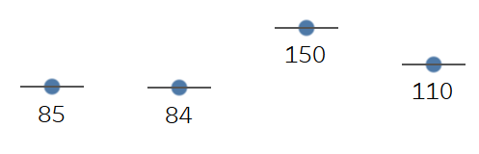  2014 2015 2016 2017 | 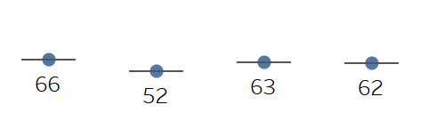  2014 2015 2016 2017
Top WR submitter
Highlights | - The timing of the next version of EANCOM 20XX version will be determined by the EDI Advisory Team and the new EDI Strategy Plan  - Updates to the GS1 Logistics Interoperability Model Application Standard were approved for ratification to align the GS1 Logistics Interoperability Model (LIM) with the latest GS1 XML and EANCOM Standard releases. | - GMD processed 58 % of all WRs entered this quarter  - The GDSN Automation project has resulted in improved release accuracy  - GDSN MR 3.1.6 is in development

Figure 3-5 GPC and ID SMG’s summary and performance, there is not enough 2018 WR closed data tp report this quarter.

 | Global Product Classification (GPC) | Identification (ID)
Median days  in  development | 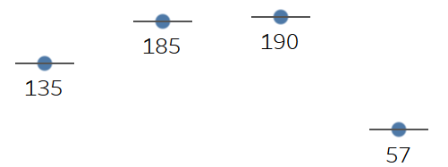  2014 2015 2016 2017 | 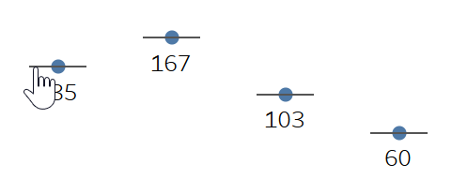  2014 2015 2016 2017
Top WR submitter
Highlights | - The GPC standard is currently translated into 21 different languages with 3 additional languages in the process of being translated for the first time  - Successfully recruited a new candidate, Sean Lightholder from Walmart, to replace Werner Kolb as co-chair due to his impending retirement  - Time to process work requests remains at an all time low | - General Specification V2018 was released in January per schedule  - Conducted a workshop to identify needs and continuous improvements for General Specification V 2019  - Advancing Identification Matters (AIM) and GS1 is in collaboration to process Sensor Application Identifier  - There is an open co-chair position  - ID SMG participants are participating in ID related activities with URI Structure MSWG and Fighting Illicit Trade MSWG
Note: 1. Traceability & Event Sharing and Data Accuracy SMG’s have minimal activity, and is therefore, not reported.
2. Performance numbers have changed slightly from previous reports due to a change in the Excel formula used to calculate the number of days in GSMP. The formula changed from “Days360” to “DATEDIF”.
Legend:
All WR for year are closed WR are still open for year

Development work
A work request is categorised as development, if it involves creation of a new standard/guideline, or significant change to existing standard/guideline and the work is completed in a Mission Specific Work Group. Examples: extension to GDSN, a new EPCglobal High Frequency (HF) Air Interface Standard, enhancement to the EPCIS Standard to include aggregation layers, a new barcode symbology, a new Business Message Standard. Development work is on time, if the work is completed in, or under the estimated time to complete. The estimated completion date is defined in the project plan at the start of the development stage. There were no development work efforts completed this quarter

Participation
Participants in GSMP are organisations (companies or other recognised entities); each organisation is represented by one or more individual persons belonging to that organisation. There is no limit to the number of individuals from a single organisation that may participate. Companies not a member of GS1 are non-voting. There are three types of participating members:
- GSMP community member (non-voting)
- Company has signed GS1 Intellectual Property (IP) Policy
- Individual has joined the GSMP group in GS1 Community Room
- GSMP community member (voting)
- Company is a member of GS1
- Company has signed GS1 Intellectual Property (IP) Policy
- Individual has joined the GSMP group in GS1 Community Room
- GSMP Work Group Member
- Company has signed the GS1 Intellectual Property (IP) Policy
- Company has signed a group Opt-in Agreement
- Member has joined the GSMP group in GS1 Community Room

GSMP company membership
Table 4-1 Number of member companies in GSMP by year
Group | 2015 | 2016 * | 2017 | 2018 ytd
Users | 442 | 496 | 317 | 364
MO’s | 56 | 56 | 52 | 55
Total | 498 | 552 | 369 | 419
* GSMP changed membership management systems in April of 2017. All companies who did not have an active associate since January 1, 2016, were archived due to inactivity

Interest category # of participants  Academia 4  Association 7  Auto-ID 3  Central Bank 5  Data Pool 6  Distributor / Group Purchasing 8  eTailer 3  Government Agency 8  GS1 Certified Data Pool 10  GS1 MO 55  Hospital 7  Logistics Provider 13  Manufacturer 125  Regulatory Body 2  Retailer 39  Solution Provider 124  Total 419  Table 4-2 Member companies by interest category | Table 4-3 Member companies by region  Region # of Companies  Asia Pacific 23  Europe 238  Latin America 15  North America 132  Middle East & Africa 11  Total 419
- GSMP has 419 active member companies in a GSMP Work Group, 363 companies are voting members and 56 companies are non-voting

Voting
Each company/organisation represents one vote in GSMP, regardless of the number of associates. GSMP requirements and standards reach approval by community eBallots. Each eBallot requires approximately 12 votes with additional supply chain role minimum votes (charter variations may apply).
- The average number of votes per ballot this quarter was 18, down from the average of 23 in 2017. 36 ballots for requirements or standards were passed this quarter.
- Event attendance

Event attendance
GS1 Global Office hosts two events every year for the GS1 community to collaborate face-to-face on industry needs and the development of GS1 standards. These events are:
- GS1 Standards Event, was held in Jersey City, USA
- GS1 Industry and Standards Event will be help in Dublin, Ireland 10-14 September

The latest GS1 Standards Event took place 19-23 March 2018 in Jersey City, USA. Attending the event were 206 individuals from 22 different countries.

Table 4-4 Event attendance by individual/organisation
By organisation | 2015  Jersey City | 2015  Warsaw | 2016  Jersey City | 2016 Brussels | 2017 Jersey  City | 2017 Brussels | 2018  Jersey City
Affiliate, Associates, Auto-ID Lab, other | 5/5 | 19/15 | 5/5 | 36/26 | 12/7 | 21/14 | 21/12
Data Pool and Solution Provider | 21/19 | 42/32 | 25/18 | 63/43 | 19/13 | 57/47 | 27/21
Distributor / Group Purchasing and Manufacturer | 28/19 | 24/16 | 30/24 | 29/25 | 17/15 | 34/27 | 22/18
Global Office staff | 51/1 | 53/1 | 49/1 | 80/1 | 50/1 | 84/1 | 53/1
GS1 MO | 84/22 | 126/30 | 82/24 | 124/27 | 92/23 | 165/32 | 74/20
Hospital and Retailer | 6/5 | 15/10 | 16/13 | 9/6 | 10/7 | 18/14 | 9/7
Total | 195/71 | 279/104 | 207/85 | 340/128 | 200/66 | 379/135 | 206/79

Quality
The GSMP defines quality as the entire process employed to ensure that all GS1 standards are user-driven, globally applicable, royalty-free (to the best of our ability) and that ultimately meets the needs and requirements defined by its members.

Due process
All GSMP groups are expected to follow the processes and procedures specified in the GSMP Manual. A community eBallot is used to confirm community consensus to progress a draft standard, or other GSMP deliverable.

Consensus
Decision-making is achieved through consensus, which is defined as approval without sustained opposition. Voting options are yes, no and abstain. Total votes cast; 4233; 3965 yes, 42 no, 226 abstain. Abstain is used when a voter is not familiar enough with the material to cast a vote, but has read through the material.
Below are measures of due process and consensus in the GSMP:
- Zero (0) due process infractions
- 94% of all eBallots approved this quarter were unanimous
- 99% of votes cast this quarter were affirmative

Satisfaction survey results
GS1 issues several surveys to measure satisfaction with GSMP. Survey results are structured in three categories:
- unfavourable = sum of very dissatisfied and fairly dissatisfied
- neutral
- favourable = sum of satisfied and very satisfied
Favourable and unfavourable answers are shown in percent using this structure: fav/unfav. Neutral answers are not used in reporting the survey results; they are viewed as opportunities to move a response to favourable. The results of the three surveys are detailed in the next three sections.

GSMP member satisfaction survey
Overall satisfaction with GSMP rose 7 percentage points for the second year in a row, and reduced unsatisfactory ratings to a 4-year low. Staff satisfaction was down 5 percentage points, but is still the second highest rating in 4 years. Satisfaction with the GSMP process itself, maintained its 50% rating, while achieving the least amount of unsatisfactory ratings in the last 4 years.
Figure 5-1 GSMP member satisfaction survey results

Table 5-1 GSMP member satisfaction survey results; satisfaction overall, with the staff, and with the process
 | 2014 |  | 2015 | 2016 |  | 2017
Questions | 20122013% FAVS/UNFAVS
Overall satisfaction with GSMP | 57/7 | 57/13 |  |  | 64/8 | 71/3
Satisfaction with GSMP staff | 73/4 | 66/9 |  |  | 81/2 | 76/3
Efficiency of process | 39/14 | 43/17 |  |  | 50/8 | 50/5

GS1 Standards events satisfaction survey results
Table 5-2 GS1 Event satisfaction survey results
Programme activity | 2015  Jersey City | 2015  Warsaw | 2016 Jersey City | 2016  Brussels | 2017 Jersey City | 2017  Brussels | 2018 Jersey City
Overall, how satisfied were you with the GS1 Standards Event? | 93/2 | 93/1 | 98/2 | 97/0 | 92/2 | 98/0 | 96/2
How satisfied were you with the event facilities? | 94/2 | 91/4 | 99/0 | 79/6 | 91/0 | 88/4 | 93/1
How satisfied were you with the week's agenda? | 75/7 | 89/11 | 96/4 | 98.2 | 88/13 | 98/2 | 95/5
How satisfied were you with the Tuesday Plenary? | 76/9 | 68/16 | 93/7 | 80/7 | 92/0 | 83/0 | 89/3
Average | 85% | 85% | 97% | 89% | 91% | 92% | 93%

GS1 Member Organisation satisfaction survey
Favourable responses from GS1 Member Organisations increased to 78%, the highest rating ever!
Figure 5-2 GSMP MO satisfaction survey results

Table 5-3 GS1 MO satisfaction survey results table
Question |  | % FAVS/UNFAVS
 | 2014 |  | 2015 | 2016 |  | 2017
Overall satisfaction with GSMP | 75/2 |  | 64/1 |  | 73/0 |  | 78/3

GSMP Governance Groups

Board Committee for Standards (BCS) members
Art Smith, GS1 Canada
Barron Witherspoon, Procter & Gamble
Carrie Wilkie, GS1 US
Elzbieta Halas, GS1 Poland
Jean-Marc Klopfenstein, Nestlé
Juan Antonio Sanfeliu, Manufacturas Antonio Gassol
Lori Schrop, J.M. Smucker Co.
Maria Palazzolo, GS1 Australia – Chair
Michael Rose, Johnson & Johnson
Miguel Lopera, GS1
Ulrich Schaefer, GS1 Germany
Vivek Balasubramanian, Amazon
Volker Zeiner, B. Braun
Xavier Barras, GS1 France

Industry Engagement Steering Committee (IESC) members
Amber Walls, GS1 US
Ana Paula Maniero, GS1 Brasil
Cédric Lecolley, GS1 France – Chair
Erin Hennessey, Procter & Gamble
Halim Recham, GS1 Algeria
Jeff Denton, Amerisource Bergen – Chair
Joachim Wilkins, C&A Europe / RSC Commercial Services
Loek Boortman, GS1 Netherlands
Marcel Sieira, GS1 Australia
Ruediger Hagedorn, Consumer Goods Forum
Virginia Vaamonde, GS1 Brasil
Yolande Diaz, Carrefour

Architecture Group (AG) members
Elizabeth Waldorf, TraceLink, Inc
Eugen Sehorz, GS1 Austria
Gina Tomassi, Pepsico
Giovanni Biffi, Logyca
Henri Barthel, GS1 GO – Chair
Jens Kungl, Metro Group
John Terwilliger, Abbott
Junyu Wang, Fudan Auto-ID Lab
Kevin Dean, GS1 Canada
Marc Cox, Philips
Mark Harrison, Milecastle Media
Paul Reid, GS1 UK
Ralph Tröger, GS1 Germany
Ray Delnicki, GS1 US
Robert Beideman, GS1 GO
Roberto Matsubayashi, GS1 Brasil
Seán Lightholder, Walmart
Sean Lockhead, GS1 GO
Staffan Olsson, GS1 Sweden
Sue Schmid, GS1 Australia – Chair
Sylvia Rubio Alegren, ICA
Tony Zhang, FSEnet
Vera Feuerstein, Nestlé – Chair
Xavier Barras, GS1 France

More information
Access this document and other GSMP reports at this website: http://www.gs1.org/gsmp/reports
Please contact Eileen Harpell with your questions or suggestions: GSMP@GS1.org

