Global Standards Management Process (GSMP)

Happy New Year to the GSMP Community!
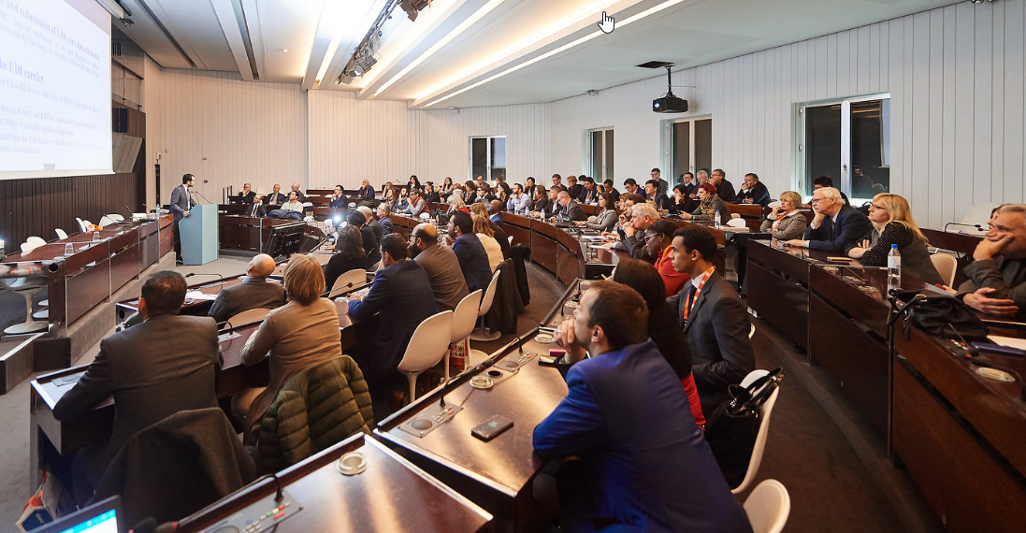
I’m pleased to share with you the results of 2018. Together, we delivered 36 critical industry driven standards, efficiently and effectively. The Measurements below show our many successes, but two reflect the quality and speed of development: 99% of the votes cast to were affirmative, that is an impressive level of consensus and the fact that our large work efforts are being completed 50% faster than just a few years ago.

Thank you for your support in 2018 and we look forward to working with you and your members in 2019. We are starting 2019 with 9 Mission Specific Work Groups actively developing new, complex industry standards to drive efficiency and reduce costs for our members, are you involved? If you would like to learn more about the exciting work, click here.

The next GS1 Standards Event will be co-located with GS1 Connect in Denver, Colorado USA on 17-18 June 2019. This enables attendees to experience developing standards and seeing them in action in one location!

Regards, Andrew Hearn; Vice President, Global Standards Development

GSMP Measurements
* Increase for GDSN Major Release and GPC Fast Moving Consumer Goods  Work Request Activity | - Improved cycle times:  51 days for 2018 Work Requests vs. 65 days for 2017 Work Requests  - 98% of all maintenance work requests completed on-time  - Overall satisfaction survey results at an all-time high!  Performance | - 99% of all votes are positive  - 89% of all eBallots were 100% affirmative  - Zero due process concerns  - Standards were voted in with almost double the votes required (on average)  Consensus

Mission Specific Groups Status Overview

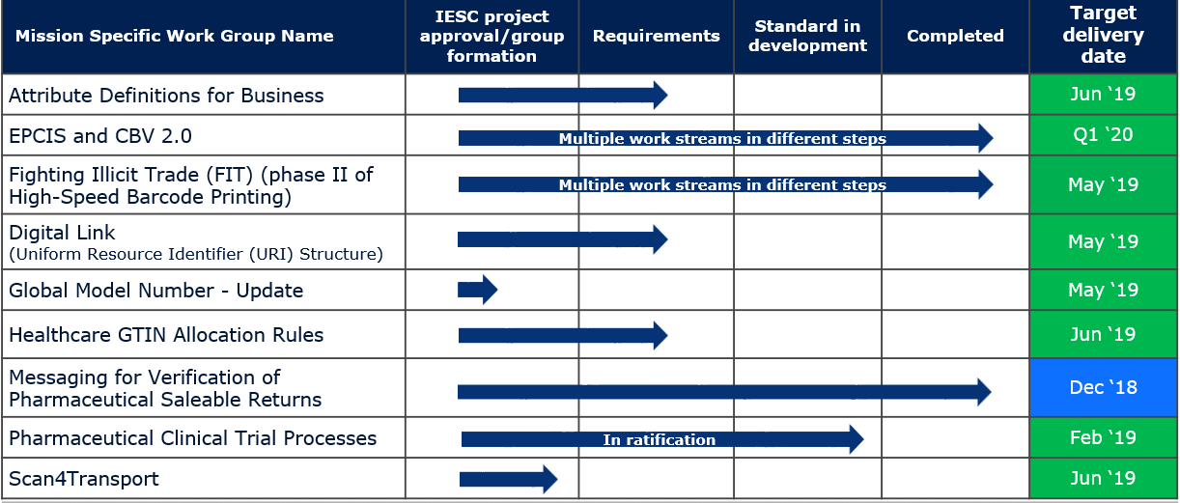

Legend: 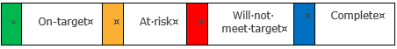

Global Standards Management Process (GSMP) Team
Jean-Luc Champion
Manager, Standards Development
David Buckley
Senior Manager, Technical Publications and Standards Development

Cindy Grell
Manager,
Community Engagement, Communications & Events
Justin Childs
Director, Standards Development

Andrew Hearn
Vice President, Standards Development
Eileen Harpell
Operations Manager, GSMP

Eddy Merrill
Operations Analyst, GSMP
Jeanette McVeigh
GPC Standards Development Leader

John Ryu
Director, Standards Development
Greg Rowe
Director, Standards Development

Tasha Wiehe
Director, Standards Development

