[insert date]
Dear [name/sir/madam],

Apple is renowned for its innovative products, sleek design and smooth user-experience in hardware, software, and mobile Apps. However, the user-experience in healthcare could be improved by enabling native scanning of the GS1 DataMatrix barcode and recognition of the data encoded on the barcode. Driven by regulatory requirements, the most widely used barcode for the identification and traceability of healthcare products is the GS1 DataMatrix barcode. Currently, a majority of native device cameras are limited to recognising the information captured in QR codes to access information, but only a very limited number of Apps are enabling a similar experience with a GS1 DataMatrix barcode.

By collaborating with the healthcare industry on aligning seamless access to online content, by scanning a QR code or a GS1 DataMatrix barcode, Apple will significantly improve users experience and will play a pivotal role in empowering developers to create the relevant Apps. This will also unlock access to extra services via the Apple Health App, such as details on how to use a medical device, reminders on smartwatch to never miss a dose, and empowering patients and improving patient safety. This transformation holds the potential to usher in a new era of innovation and improved functionality in the realm of healthcare industries, supporting better patient outcomes.

Today, more than 6.5 billion packs of medicines per year in the U.S.A. and more than 10 billion packs of prescription medicines per year in the E.U. are identified via a GS1 DataMatrix barcode. This broad and consistent implementation is similarly relevant for billions of donated healthcare products on which the GS1 DataMatrix barcode enables to ensure visibility of the product across the supply chain and authentication of the products supplied to low- and medium-income countries. The GS1 DataMatrix barcode is also commonly used to meet Unique Device Identification (UDI) requirements in many countries across the globe.

There are many reasons for the choice of the GS1 DataMatrix barcode, the most important are:

• Captures the largest amount of identification data in the smallest amount of space on packaging,
• Can be printed directly on the products,
• Has sophisticated error detection and correction algorithms, allowing the GS1 DataMatrix barcode to be scanned even if damaged, torn or printed poorly.

However, increasingly an additional QR code is often applied on the label or packaging of healthcare products to provide access to electronic information about a product. Identifying the correct product or accessing online content by scanning a barcode become challenging when multiple barcodes are present on a single pack. The use of QR codes is growing because only
commercial barcode scanners and certain Apps in the Apple App store are able to read the GS1 DataMatrix barcodes and link it to online with information whereas the QR code be natively read and ‘understood’ by mobile devices.

Enabling this scanning process needs to be simple and efficient, using a mobile device (e.g. a phone or a tablet), is crucial to ensure wide scale adoption can be achieved. The benefits of enabling a barcode scan to facilitate access to online information includes combating substandard or counterfeit medicine or device, reducing medical errors and expediting recalls. The emerging Regulations in Circular Economy and ESG (Environment, Social and Governance) will push us towards providing more transparency on material sourcing and ethical manufacturing data, that could be accessed via a barcode scan.
Furthermore, this initiative helps improve access to accurate medical information about donated healthcare products in relevant languages for migrating populations under crises and with limited access to technology infrastructure support.
Facilitating access could provide Apple users with the information needed using their mobile devices without the need of downloading an extra App and would further facilitate the integration with wearable devices.

To empower the mobile phone App developers to unlock these benefits for Apple users and meet the needs of the healthcare stakeholders, Apple would need to enable the following features:
1. That the native camera application recognises Data Matrix (ISO/IEC 16022:2006).
2. That the native camera application recognises the “GS1 element string syntax” in addition to the structures already recognised in QR Codes.
3. That Apps can declare their capability to “recognise GS1” element string syntax so that the native camera can hand off to the relevant App (e.g. similar to how the scanning of a barcode provides pop-up windows to search on Google or launch Amazon)

We would like to extend an invitation to Apple to join a collaborative workgroup mid-March 2024. This initiative will unite the key stakeholders from the healthcare global community to initiate the transformation required. To confirm Apple’s participation to this workshop and to discuss any questions you might have, please do not hesitate to come back to me.

Sincerely,
[Your name]
Appendix

The user experience today
If a user wants to scan a DataMatrix barcode with a smartphone today, they will need to:
- Recognise that the barcode is something they can scan. They may try to scan it like a QR code and be frustrated that it doesn’t work, or they may recognise that it’s not a QR code and …
- Open an App that they know can scan a DataMatrix and ‘understand’ the information in the barcode.
- Scan that barcode and use the information needed.
- Brands and health authorities have to work hard to share education, and to develop and promote the relevant Apps.

The desired experience
- A user sees a barcode and opens the camera on his/her mobile device to scan the barcode.
- The camera fires up an installed App that enables scanning the barcode and displays the information.
- Manufacturers continue to use their chosen barcode with no change while unlocking all benefits of a simple access to online information for patients and healthcare providers.

Barcodes required/used for traceability and/or access digital content

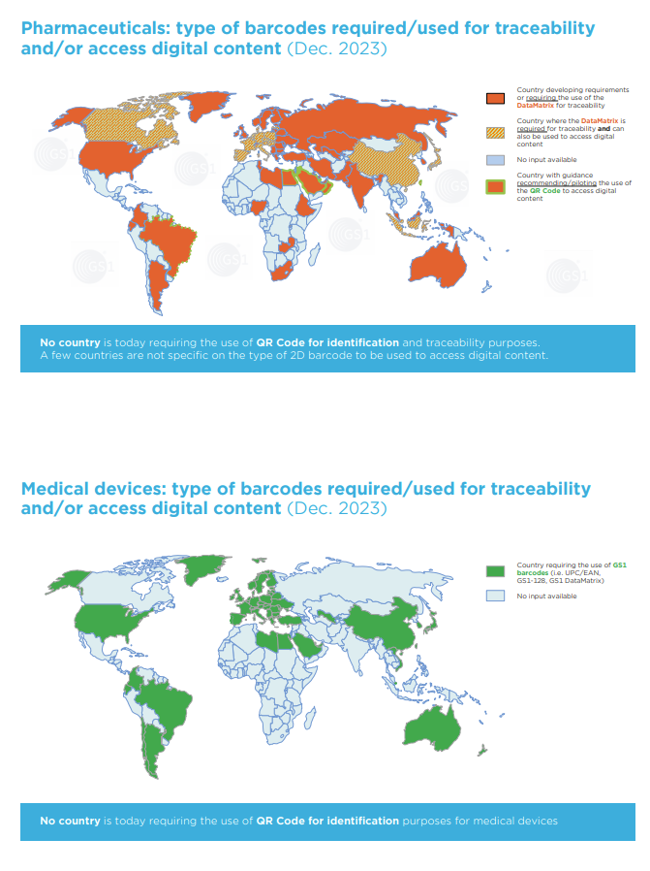

https://www.ghsupplychain.org/global-standards-technical-implementation-guideline-global-health-commodities Global Standards Technical Implementation Guideline for Global Health Commodities endorsed by the Bill and Melinda Gates Foundation, Gavi, Global Drug Facility, UNDP, UNICEF, UNFPA and USAID
https://www.gs1.org/docs/healthcare/position-papers/GS1-DataMatrix-Position-Paper-FINAL.pdf
https://www.gs1.org/sites/gs1/files/2023-12/gs1seg231205-01-for_hclt_gs1_stds_to_access_digital-content_in_hc_a4_08.pdf

